# Team Oscar Bug Report

|  |  |
| --- | --- |
| Bug Name: | Null property |
| Description: | Properties with null values can be saved. |
| Test Case: | testSaveNullProperties() |
| Location of error: | DataWriter class, saveProperties method |

|  |  |
| --- | --- |
| Bug Name: | Empty property |
| Description: | Properties with empty values can be saved. |
| Test Case: | testSaveEmptyProperties() |
| Location of error: | DataWriter class, saveProperties method |

|  |  |
| --- | --- |
| Bug Name: | Null user |
| Description: | Users with null values can be saved. |
| Test Case: | testSaveNullPeople() |
| Location of error: | DataWriter class, savePeople method |

|  |  |
| --- | --- |
| Bug Name: | Empty user |
| Description: | Users with empty values can be saved. |
| Test Case: | testSaveEmptyPeople() |
| Location of error: | DataWriter class, savePeople method |

|  |  |
| --- | --- |
| Bug Name: | Add property |
| Description: | Property does not save properly. |
| Test Case: | testAddProperty() |
| Location of error: | HousingApplication class, addProperty method |

|  |  |
| --- | --- |
| Bug Name: | Create account |
| Description: | Created account does not save properly. |
| Test Case: | testCreateAccount() |
| Location of error: | HousingApplication class, createAccount method |

Data Loader Test Coverage:

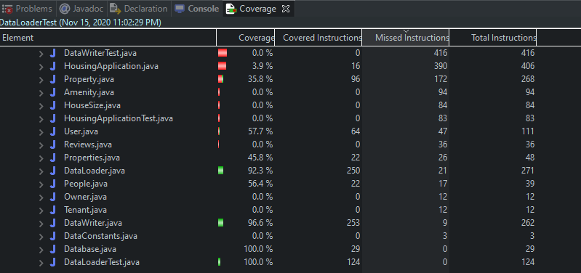

Data Writer Test Coverage:

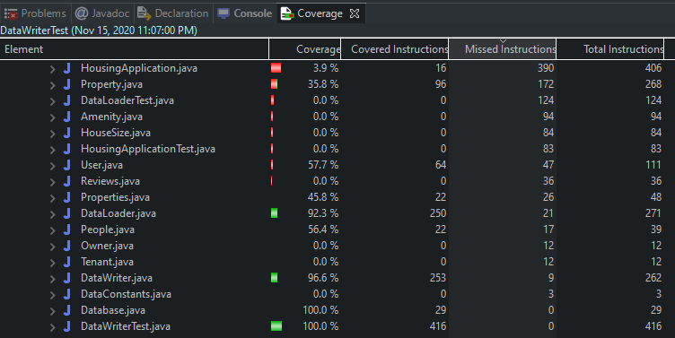

Housing Application Test Coverage:

